LAPORAN PRAKTIK

PEMOGRAMAN PYTHON

**GUI PROGRAMMING**



**Disusun oleh :**

Ody Frans Wijaya

V3922037

**Dosen :**

Yusuf Fadila Rachman S.Kom,M.Kom

**PS D-III TEKNIK INFORMATIKA**

**SEKOLAH VOKASI**

**UNIVERSITAS SEBELAS MARET**

**2023**

**HASIL DAN PENJELASAN**

1. Tampilan GUI kalkulator sederhana menggunakan python

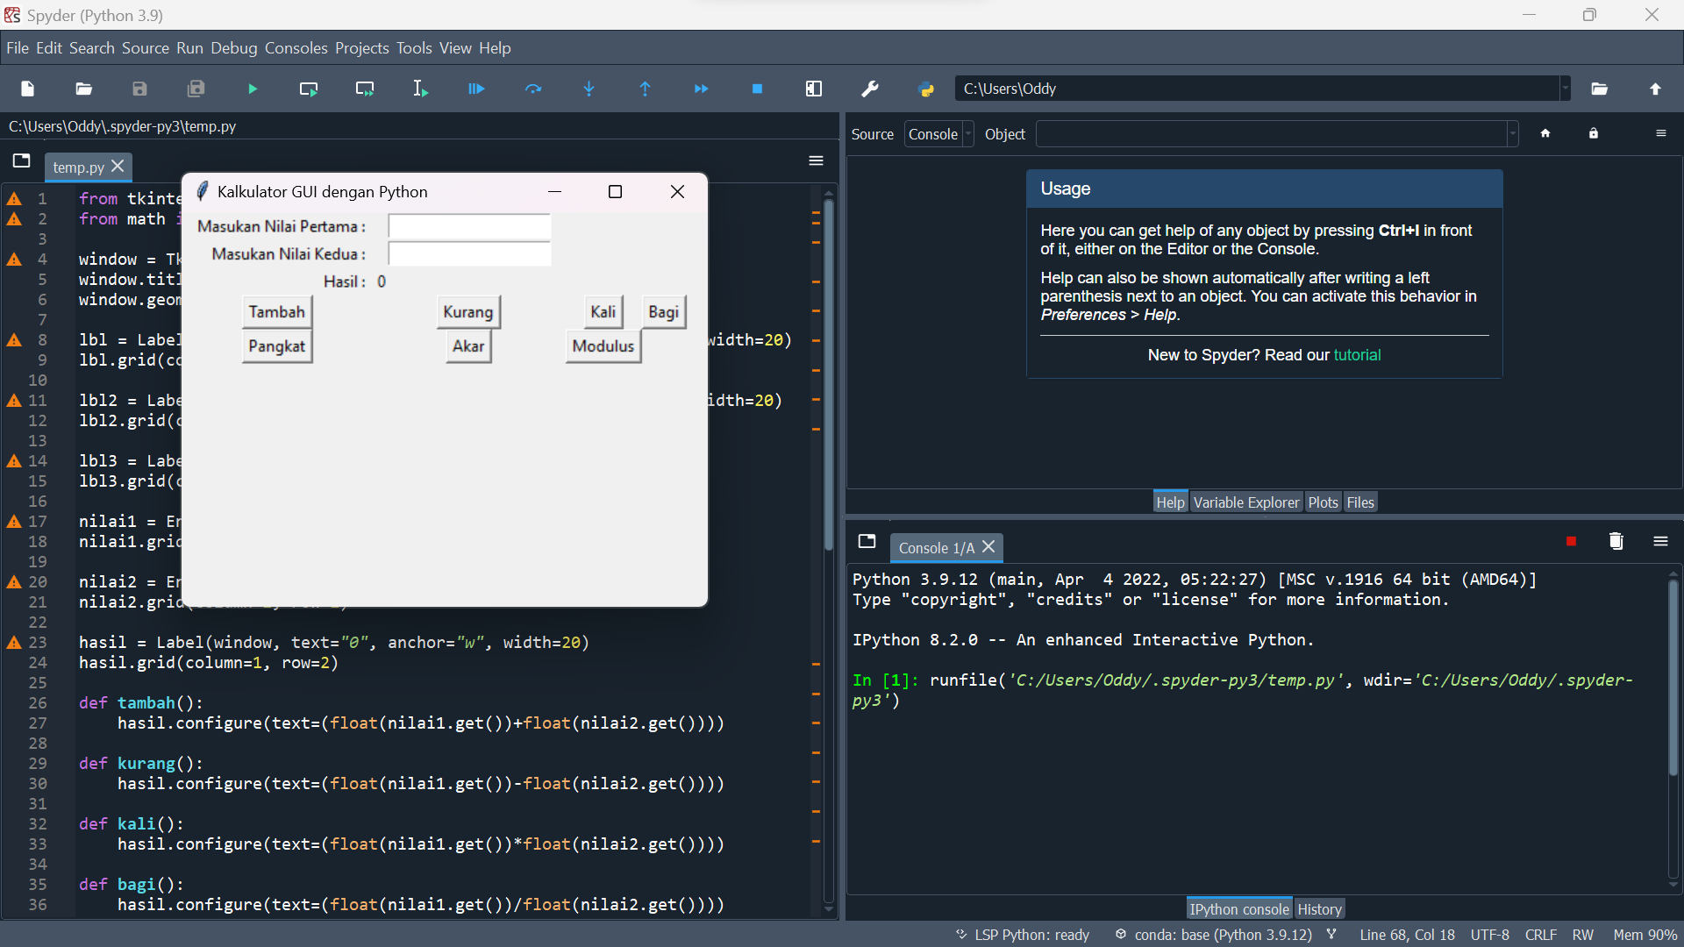

2. Script yang saya gunakan

from tkinter import *

from math import pow, sqrt

window = Tk()

window.title("Kalkulator GUI dengan Python")

window.geometry('400x300')

lbl = Label(window, text="Masukan Nilai Pertama : ", anchor="e", width=20)

lbl.grid(column=0, row=0)

lbl2 = Label(window, text="Masukan Nilai Kedua : ", anchor="e", width=20)

lbl2.grid(column=0, row=1)

lbl3 = Label(window, text="Hasil : ", anchor="e", width=20)

lbl3.grid(column=0, row=2)

nilai1 = Entry(window, width=20)

nilai1.grid(column=1, row=0)

nilai2 = Entry(window, width=20)

nilai2.grid(column=1, row=1)

hasil = Label(window, text="0", anchor="w", width=20)

hasil.grid(column=1, row=2)

def tambah():

hasil.configure(text=(float(nilai1.get())+float(nilai2.get())))

def kurang():

hasil.configure(text=(float(nilai1.get())-float(nilai2.get())))

def kali():

hasil.configure(text=(float(nilai1.get())*float(nilai2.get())))

def bagi():

hasil.configure(text=(float(nilai1.get())/float(nilai2.get())))

def pangkat():

hasil.configure(text=(pow(float(nilai1.get()), float(nilai2.get()))))

def akar():

hasil.configure(text=(pow(float(nilai1.get()), 1/float(nilai2.get()))))

def modulus():

hasil.configure(text=(float(nilai1.get())%float(nilai2.get())))

btnTambah = Button(window, text="Tambah", command=tambah)

btnTambah.grid(column=0, row=3)

btnKurang = Button(window, text="Kurang", command=kurang)

btnKurang.grid(column=1, row=3)

btnKali = Button(window, text="Kali", command=kali)

btnKali.grid(column=2, row=3)

btnBagi = Button(window, text="Bagi", command=bagi)

btnBagi.grid(column=3, row=3)

btnPangkat = Button(window, text="Pangkat", command=pangkat)

btnPangkat.grid(column=0, row=4)

btnAkar = Button(window, text="Akar", command=akar)

btnAkar.grid(column=1, row=4)

btnModulus = Button(window, text="Modulus", command=modulus)

btnModulus.grid(column=2, row=4)

window.mainloop()